Table of Contents

PART I: Business Rules and Data Modeling 3

Executive Summary 3

**Business Rules** 4

Entity Relationship Diagram (ERD) 8

Relational Notation 8

The Schema Data Dictionary 8

PART II: Implementation -SQL Related 11

Table Creation & Insertion 11

15 Queries 17

PART III: Implementation - Advanced SQL Related 22

PART IV: Setup MySQL Database Server and PHP Web App 25

MySQL Scripts 25

PHP Scripts 35

Javascript 39

PHP Web App 44

# **PART I: Business Rules and Data Modeling**

## **Executive Summary**

Hotel Management System is an information system which streamlines day to day business operations in hotels and helps the management team deliver excellent guest experience. In this project, we will explore the business case operations, the main actors, processes, and events of the system database. The Hotel Management System has transformed the hotel industry to become more efficient and provide better services at minimized cost. It allowed a hotel or group of hotels to handle functions such as reservation booking, guest check-in/out, room pricing, and invoicing.

Traditionally, hotel management systems were restricted to on-premises solutions, which required clients to install it on PCs at their physical location. Recently, service users have been able to operate their software system in its entirety from anywhere they have access to internet connection.

The key features and functionalities include, Hotel Web Booking Engine Software, Front Desk System, Housekeeping Solution, Billing and Invoicing System, Reporting and Analytics Solutions, etc. A sophisticated hotel management system can combine all that complexity into one centralized location by keeping precise records of all the work that have to be done. It will allow the hotel customers the ability to select the options they desire in an easy-to-use way. Further, reservations are received from numerous channels, which must all be linked to a centralized hotel payment and invoicing system.

In this project, we have developed a database system which is one of the most crucial aspects of the hotel management system.

### **Business Rules**

In the Hotel Management System database, there are the following core primary building blocks i.e., entity and their attributes.

**Hotel**– This entity comprises details of hotel attributes that include Hotel ID, Hotel Name, and Hotel Location. The Hotel ID uniquely identifies the hotel which makes it the primary key of this entity.

**Customer**– Customer entity contains important attributes applicable to this service such as Customer ID, Customer First Name, Customer Last Name, Customer Email Address, Customer Phone Number, and Customer Address. Customer ID has to always be unique to represent each customer distinctively.

**Room**– This entity consists of room-related data that mostly includes Room ID, Room Number, Room Type, Room Price, Room Availability, and Hotel ID. Each room is assigned a different Room ID that serves as a primary key.

**Reservation**- Any data related to bookings fall under this entity. The attributes consist of Reservation ID, Reservation Date, and Reservation Period. The Reservation ID is a primary key of this entity.

**Payment-** This entity is composed of payment attributes, namely Payment ID, Payment Date, and Payment Method. The Payment ID is a unique identifier of the Payment entity, so primary key.

**Review –** Customer Reviews will be stored in this entity. It consists of Review ID, Feedback, Rate. The Review ID will be assigned to identify the table.

**Invoice –** This entity contains details of invoice. Invoice ID, Issue Date will be attributes, and while Invoice ID is primary key.

|  |  |
| --- | --- |
| **Entities** | **Business Rule that describes the attributes of the given entities** |
| **Hotel** | Hotel ID: Identification code given for each hotel. |
| Hotel Name: The name of the hotel |
| Hotel Location: The location of the hotel |
| **Customer** | Customer ID: Identity code assigned to a person |
| Customer First Name: The first name of the customer |
| Customer Last Name: The last name of the customer |
| Customer Email Addres: Email address of the person |
| Customer Phone Number: Phone number of the customer |
| Customer Address: An address the person currently lives in |
| **Room** | Room ID: A code given to each room |
| Room Number: Hotel room number |
| Room Type: Whether the room is family or standard |
| Room Price : The price set for each room |
| Room Availability : Whether the room is available at the moment |
| **Reservation** | Reservation ID : The generated code while making reservation and unique for every reservation |
| Reservation Date : The date on which the reservation is made |
| Reservation Period : For how long the customer is staying |
| **Payment** | Payment ID : The Unique ID for each payment |
| Payment Date : The date which the payment completed on |
| Payment Method: How the payment took place |

|  |  |  |
| --- | --- | --- |
| **Relationships** | | |
| **Customer Vs Reservation** | Customer can make many Reservations:|o ----|< | 1-M |
| **Hotel Vs Room** | Hotel can have many Rooms :||-----o< | 1-M |
| **Room vs Reservation** | Room can be reserved many times: ||-----o< | 1-M |
| **Customer vs Payment** | Customer can make many Payments ||-----o< | 1-M |
| **Customer vs Review** | Customer can make many Reviews ||-----o< | 1-M |
| **Payment vs Reservation** | One Payment is made for one Reservation ||----|| | 1-1 |
| **Payment vs Invoice** | One Payment can generate one Invoice :||-----o| | 1-1 |

|  |  |  |  |  |
| --- | --- | --- | --- | --- |
| **Entity** | **Attributes** | **Column Name** | **Types** | **Identifiers** |
| **Hotel** | Hotel ID | **Hotel_ID** | **Char(20)** | **PK** |
| Hotel Name | **Hotel_Name** | **Varchar(40)** |  |
| Hotel Location | **Hotel_Loc** | **Varchar(40)** |  |
| **Customer** | Customer ID | **Cust_ID** | **Char(8)** | **PK** |
| Customer First Name | **Cust_FName** | **Varchar(30)** |  |
| Customer Last Name | **Cust_LName** | **Varchar(30)** |  |
| Customer Email Address | **Cust_Email** | **Varchar(30)** |  |
| Customer Phone Number | **Cust_Phone_No** | **Varchar(20)** |  |
| Customer Address | **Cust_Address** | **Varchar(20)** |  |
| **Room** | Room ID | **Room_ID** | **Char(8)** | **PK** |
| Room Number | **Room_No** | **Varchar(10)** |  |
| Room Type | **Room_Type** | **Varchar(10)** |  |
| Room Price | **Room_Price** | **Number(7,2)** |  |
| Room Availability | **Room_Availability** | **BIT** |  |
| Hotel ID | **Hotel_ID** | **Char(8)** | **FK** |
| **Reservation** | Reservation ID | **Reserv_ID** | **Char(8)** | **PK** |
| Reservation Date | **Reserv_Date** | **date** |  |
| Reservation Period | **Reserv_Period** | **Number(4)** |  |
| Customer ID | **Cust_ID** | **Char(8)** | **FK** |
| Room ID | **Room_ID** | **Char(8)** | **FK** |
| **Payment** | Payment ID | **Payment_ID** | **Char(8)** | **PK** |
| Payment Date | **Payment_Date** | **Date** |  |
| Payment Method | **Payment_Method** | **Varchar(10)** |  |
| Customer ID | **Cust_ID** | **Char(8)** | **FK** |
| Reservation ID | **Reserv_ID** | **Char(8)** | **FK** |
| **Review** | Review Id | **Review_ID** | **Char(8)** | **PK** |
| Feedback | **Feedback** | **Varchar(256)** |  |
| Rate | **Rate** | **Varchar(10)** |  |
| Customer ID | **Cust_ID** | **Char(8)** | **FK** |
| Reservation ID | **Reserv_ID** | **Char(8)** | **FK** |
| **Invoice** | Invoice ID | **Invoice_ID** | **Char(8)** | **PK** |
| Issue Date | **Issue_Date** | **Date** |  |
| Payment ID | **Payment_ID** | **Char(8)** | **FK** |

## **Entity Relationship Diagram (ERD)**

## **Relational Notation**

**Hotel**(**Hotel ID,** Hotel Name, Hotel Location)

**Customer**(**Customer ID,** Customer First Name, Customer Last Name, Customer Email Address, Customer Phone Number, Customer Address)

**Room**(**Room ID**, Room Number, Room Type, Room Price, Room Availability, Hotel ID*)

**Reservation**(**Reservation ID**, Reservation Date, Reservation Period, Customer ID*,Room ID*)

**Payment**(**Payment ID**, Payment Date, Payment Method, Customer ID*, Reservation ID*)

Review(**Review_ID**, Feedback, Rate, Customer ID*, Reservation ID*)

Invoice(**Invoice ID**, Issue Date, Payment ID*)

## **The Schema Data Dictionary**

|  |  |  |  |  |  |  |  |  |
| --- | --- | --- | --- | --- | --- | --- | --- | --- |
| Table Name | Attribute Name | Contents | Type | Format | Range | Required | PK or FK | FK Referenced Table |
| Customer | Cust_ID  Cust_FName  Cust_LName  Cust_Email  Cust_Phone_No  Cust_Address | Customer ID  Customer Frist Name  Customer Last Name  Customer Email Customer Phone Number  Customer Address | Char(8)  Varchar(30)  Varchar(30)  Varchar(30)  Varchar(20)  Varchar(20) |  |  | Yes  Yes  Yes  Yes | PK |  |
| Hotel | Hotel_ID  Hotel_Name  Hotel_Loc | Hotel ID  Hotel Name  Hotel Location | Char(8)  Varchar(40)  Varchar(40) |  |  | Yes  Yes  Yes | PK |  |

|  |  |  |  |  |  |  |  |  |
| --- | --- | --- | --- | --- | --- | --- | --- | --- |
| Room | Room_ID  Room_No  Room_Type  Room_Price  Room_Availability  Hotel_ID | Room ID  Room Number  Room Type  Room Price  Room Availability  Hotel ID | Char(8)  Varchar(10)  Varchar(10)  Number(7,2)  BIT  Char(8) |  |  | Yes  Yes  Yes  Yes  Yes  Yes | PK  FK | Hotel |
| Reservation | Reserv_ID  Reserv_Date  Reserv_Period  Cust_ID  Room_ID | Reservation ID  Reservation Date  Reservation Period  Customer ID  Room ID | Char(8)  Date  Number(4)  Char(8)  Char(8) | dd-mmm-yyyy |  | Yes  Yes  Yes  Yes  Yes | PK  FKFK | Customer  Room |
| Payment | Payment_ID  Payment_Date  Payment_Method  Cust_ID  Reserv_ID | Payment ID  Payment Date  Payment Method  Customer ID | Char(8)  Date  Varchar(10)  Char(8)  Char(8) | dd-mmm-yyyy |  | Yes  Yes  Yes  Yes  Yes | PK  FK FK | Customer  Reservation |
| Invoice | Invoice_ID  Issue_Date  Payment_ID | Invoice ID  Issue Date  Payment ID | Char(8)  Date  Char(8) | dd-mmm-yyyy |  | Yes  Yes  Yes | PK  FK | Payment |
| Review | Review_ID Feedback  Rate  Cust_ID | Review ID  Feedback  Rate  Customer ID | Char(8)  Varchar(256)  Number(1)  Char(8)  Char(8) |  |  | Yes  No  No  Yes | PK  FK | Customer |
| FK= Foreign Key  PK=Primary Key  Varchar = The Varchar data type can store a character string of a maximum length of 65535 bytes of characters.  Char = The Varchar data type can store a character string of a maximum length of 8,000, bytes of characters. | | | | | | | | |

# **PART II: Implementation -SQL Related**

## **Table Creation & Insertion**

CREATE TABLE Customer (

cust_id char(8) not null,

cust_Fname varchar(30) not null,

cust_Lname varchar(30) not null,

cust_Email varchar(30) not null,

cust_Phone_No varchar(20),

cust_Address varchar(20),

constraint pk_customer primary key(cust_id)

);

INSERT INTO Customer VALUES('1','Emmalynn','Pimerick','epimerick0@hostgator.com','311-315-8577','Poland');

INSERT INTO Customer VALUES('2','Brnaba','Gorry','bgorry1@canalblog.com','459-614-7277','Philippines');

INSERT INTO Customer VALUES('3','Jerrine','Gorman','jgorman2@mashable.com','663-243-7418','France');

INSERT INTO Customer VALUES('4','Joey','Hatwell','jhatwell3@intel.com','264-985-0938','China');

INSERT INTO Customer VALUES('5','Poul','Fuge','pfuge4@vinaora.com','304-838-7585','Tunisia');

INSERT INTO Customer VALUES('6','Dex','Sifflett','dsifflett5@ox.ac.uk','259-984-5382','Brazil');

INSERT INTO Customer VALUES('7','Franky','Covotto','fcovotto6@uiuc.edu','542-435-0473','Macedonia');

INSERT INTO Customer VALUES('8','Lamond','Gerrie','lgerrie7@blogspot.com','791-723-4674','China');

INSERT INTO Customer VALUES('9','Vivienne','Pullin','vpullin8@wikipedia.org','248-841-1074','Albania');

INSERT INTO Customer VALUES('10','Jarred','Stainton - Skinn','jstaintonskinn9@sphinn.com','561-728-5819','France');

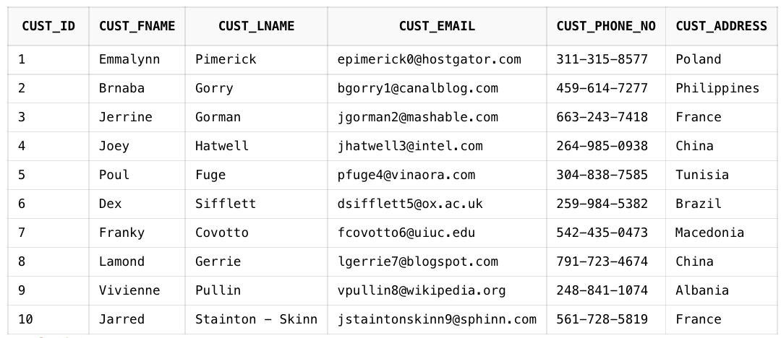

CREATE TABLE Review(

review_id char(8) not null,

feedback varchar(255),

rate number(1) check(rate <= 5),

cust_id char(8) not null,

constraint pk_review primary key(review_id),

constraint fk_review_customer foreign key(cust_id) references Customer(cust_id)

);

INSERT INTO REVIEW VALUES('1','Great view of Dubai skyline,pool area is very relaxing and clean. The room is very luxurious with a big bath and modern decor room. The gym is great, has a lot of equipment',5,'1');

INSERT INTO REVIEW VALUES('2','The beds are comfortable and there is plenty of drawers and closets for a full week or more for a family in the room.',4,'10');

INSERT INTO REVIEW VALUES('3','Gorgeous design, friendly staff, clean and safe atmosphere. Fantastic restaurants and cafe within. We also booked couples massages. We enjoyed the pool and variety of options if we stayed in.',5,'3');

INSERT INTO REVIEW VALUES('4','The lobby is just breathtaking and we had gone through the VIP check in majlis. Our room (regal suite) is very spacious and elegant. The bathroom and Closet room was just marvelous.',4,'8');

INSERT INTO REVIEW VALUES('5','Clean, fun, great breakfast, and fantastic service! Nice central location as well. Highly recommend as it is a great price you can’t beat for the quality received. Cinema and dining added bonus.',3,'5');

INSERT INTO REVIEW VALUES('6','Well managed, clean spot with great Thai cuisine, good Lebanese restaurant. The pools and facilities are new and of high standard. Its a great idea to organize the cinema events at the beach at night time.',4,'9');

INSERT INTO REVIEW VALUES('7','The gym is very good and well equipped. The sauna and steam room were a real highlight too. The rooms are spacious, clean and comfortable. All the staff are friendly, welcoming and so helpful.',5,'7');

INSERT INTO REVIEW VALUES('8','The room was spacious, with a comfy bed. Breakfast was fantastic, with accommodating staff. The hotel has an excellent pool with an exciting shape. It indeed was definitely would come again hotel.',4,'4');

INSERT INTO REVIEW VALUES('9','Location is also good, most things a short taxi ride away. Swimming pool, gym and spa available. Samuel and Anil did a really good job of servicing our rooms, always getting us what we need.',4,'2');

INSERT INTO REVIEW VALUES('10','This resort was absolutely beautiful, great location, great facilities, great staff and wonderful food in the Crescendo Restaurant. Lagoon pool rooms were beautiful and very clean.',5,'6');

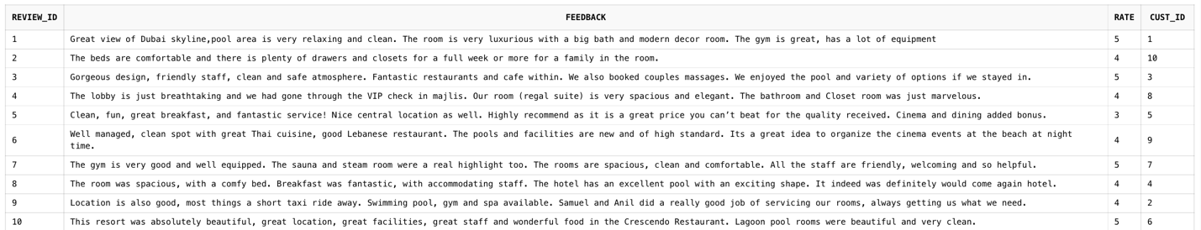

CREATE TABLE Hotel (

hotel_id char(8) not null,

hotel_name varchar(40) not null,

hotel_loc varchar(40) not null,

Constraint pk_hotel primary key(hotel_id)

);

INSERT INTO HOTEL VALUES('1','Scarlet Horizon Hotel','45 Buell Plaza');

INSERT INTO HOTEL VALUES('2','Lord Monarch Hotel','74 Summerview Drive');

INSERT INTO HOTEL VALUES('3','Rau, Schiller & Crooks','78416 Rowland Avenue');

INSERT INTO HOTEL VALUES('4','Dual Aegis Resort','58 Dennis Lane');

INSERT INTO HOTEL VALUES('5','Mellow Cosmos Hotel','8 Dryden Hill');

INSERT INTO HOTEL VALUES('6','Twin Phoenix Hotel','81 Browning Road');

INSERT INTO HOTEL VALUES('7','Riverside Bliss Hotel','0 Cardinal Road');

INSERT INTO HOTEL VALUES('8','Nicolas-Nitzsche','490 Coolidge Drive');

INSERT INTO HOTEL VALUES('9','Sunny Estate Hotel & Spa','222 Vidon Pass');

INSERT INTO HOTEL VALUES('10','Serene Gem Hotel','0000 Esker Parkway');

CREATE TABLE Room (

room_id char(8) not null,

room_no varchar(10) not null,

room_type varchar(10) not null,

room_price number(7,2) not null,

room_availability char(1) not null,

hotel_id char(8) not null,

constraint pk_room primary key(room_id),

constraint fk_room_hotel foreign key(hotel_id) references Hotel(hotel_id)

);

INSERT INTO ROOM VALUES('1','2-01','Single',181.76,'T','1');

INSERT INTO ROOM VALUES('2','2-02','Double',222.82,'F','2');

INSERT INTO ROOM VALUES('3','2-11','Triple',265.03,'F','3');

INSERT INTO ROOM VALUES('4','2-42','King',1137.79,'T','4');

INSERT INTO ROOM VALUES('5','3-15','Queen',782.72,'T','5');

INSERT INTO ROOM VALUES('6','2-23','Twin',569.74,'T','6');

INSERT INTO ROOM VALUES('7','4-09','Quad',1073.14,'T','7');

INSERT INTO ROOM VALUES('8','4-01','Double',2254.51,'F','8');

INSERT INTO ROOM VALUES('9','3-19','Suite',3419.20,'F','9');

INSERT INTO ROOM VALUES('10','2-13','Single',395.92,'T','10');

CREATE TABLE Reservation (

reserv_id char(8) not null,

reserv_date date not null,

reserv_period number(2) not null,

room_id char(8) not null,

cust_id char(8) not null,

constraint pk_reservation primary key(reserv_id),

constraint fk_reservation_customer foreign key(cust_id) references Customer(cust_id),

constraint fk_reservation_room foreign key(room_id) references Room(room_id)

);

INSERT INTO RESERVATION VALUES('1','24-JAN-22',23,'1','1');

INSERT INTO RESERVATION VALUES('2','15-Nov-2022',11,'2','2');

INSERT INTO RESERVATION VALUES('3','07-Dec-2022',28,'3','3');

INSERT INTO RESERVATION VALUES('4','15-Jan-2023',28,'4','4');

INSERT INTO RESERVATION VALUES('5','07-Dec-2022',14,'5','5');

INSERT INTO RESERVATION VALUES('6','23-Jan-2023',10,'6','6');

INSERT INTO RESERVATION VALUES('7','09-Dec-2022',9,'7','7');

INSERT INTO RESERVATION VALUES('8','04-Jan-2023',18,'8','8');

INSERT INTO RESERVATION VALUES('9','07-Dec-2022',15,'9','9');

INSERT INTO RESERVATION VALUES('10','01-Jan-2023',26,'10','10');

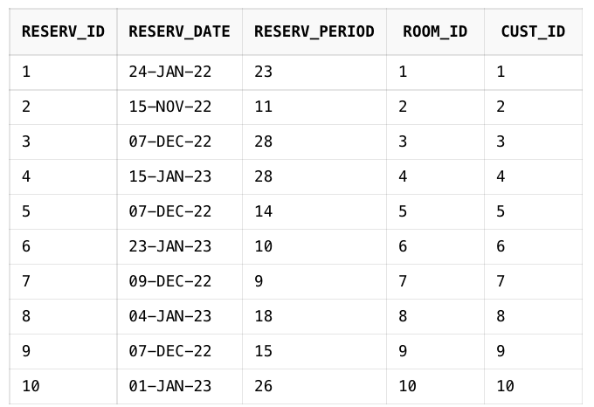

CREATE Table Payment (

payment_id char(8) not null,

payment_date date not null,

payment_method varchar(10) not null,

cust_id char(8) not null,

reserv_id char(8) not null,

constraint pk_payment primary key(payment_id),

constraint fk_payment_customer foreign key(cust_id) references Customer(cust_id),

constraint fk_payment_reservation foreign key(reserv_id) references Reservation(reserv_id)

);

INSERT INTO PAYMENT VALUES('1','31-Dec-2022','card',1,1);

INSERT INTO PAYMENT VALUES('2','07-Jan-2023','cash',2,2);

INSERT INTO PAYMENT VALUES('3','13-Dec-2022','cash',3,3);

INSERT INTO PAYMENT VALUES('4','29-Jan-2023','card',4,4);

INSERT INTO PAYMENT VALUES('5','13-Dec-2022','cash',5,5);

INSERT INTO PAYMENT VALUES('6','08-Jan-2023','card',6,6);

INSERT INTO PAYMENT VALUES('7','11-Nov-2022','card',7,7);

INSERT INTO PAYMENT VALUES('8','18-Jan-2023','cash',8,8);

INSERT INTO PAYMENT VALUES('9','03-Nov-2022','card',9,9);

INSERT INTO PAYMENT VALUES('10','12-Dec-2022','card',10,10);

CREATE TABLE Invoice (

invoice_id char(8) not null,

issue_date date not null,

payment_id char(8) not null,

constraint pk_invoice primary key(invoice_id),

constraint fk_invoice_payment foreign key(payment_id) references Payment(payment_id)

);

INSERT INTO INVOICE VALUES('1','01-Feb-2023','1');

INSERT INTO INVOICE VALUES('2','15-Dec-2022','2');

INSERT INTO INVOICE VALUES('3','28-Dec-2022','3');

INSERT INTO INVOICE VALUES('4','02-Dec-2022','4');

INSERT INTO INVOICE VALUES('5','27-Dec-2022','5');

INSERT INTO INVOICE VALUES('6','07-Dec-2022','6');

INSERT INTO INVOICE VALUES('7','13-Jan-2023','7');

INSERT INTO INVOICE VALUES('8','06-Dec-2022','8');

INSERT INTO INVOICE VALUES('9','02-Nov-2022','9');

INSERT INTO INVOICE VALUES('10','03-Feb-2023','10');

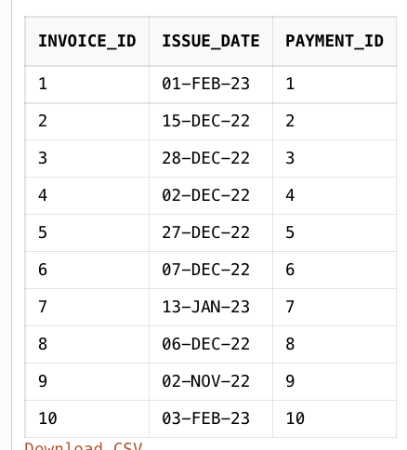

## **15 Queries**

1. Display Customer along with the hotel and room number as well as the day they booked.

select * from Reservation;

select customer.cust_fname,customer.cust_lname, hotel.hotel_name, room.room_no, reservation.reserv_date

from customer, hotel, room, reservation

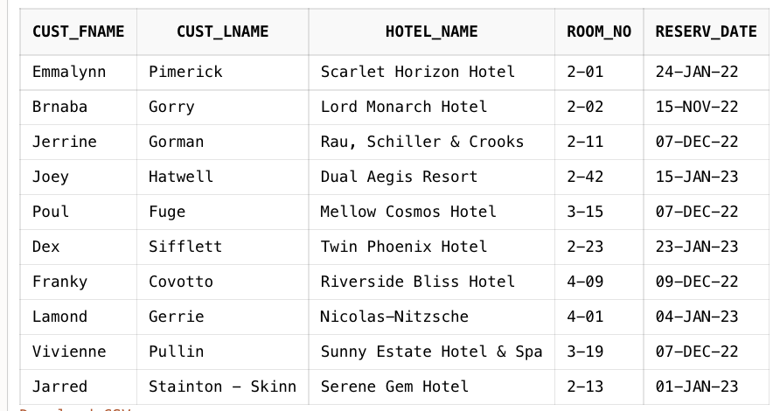where reservation.cust_id = customer.cust_id and reservation.room_id = room.room_id and room.hotel_id = hotel.hotel_id;

1. Create a view table which consists of query #1.

create view hotel_reservation as

select customer.cust_fname,customer.cust_lname, hotel.hotel_name, room.room_no, reservation.reserv_date

from customer, hotel, room, reservation

where reservation.cust_id = customer.cust_id and reservation.room_id = room.room_id and room.hotel_id = hotel.hotel_id;

1. Display only available rooms in hotels ordered by their prices in AED.

select h.hotel_name, r.Room_no,r.room_price || ' AED', r.room_availability

from hotel h, room r

where r.hotel_id = h.hotel_id and r.room_availability= 'T'

order by r.room_price;

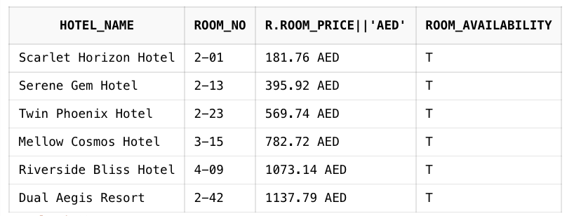

1. Count and group by customers depending on the payment method used.

select payment_method, count(*) as Transaction_Count from payment group by payment_method;

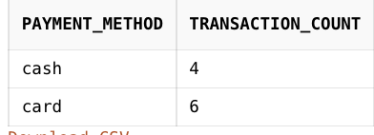

1. Display rooms with price ranging from 500 to 1500 and type in 'Triple','King','Queen','Suite.

select h.hotel_name,r.room_type,r.room_price

from hotel h, room r

where h.hotel_id = r.hotel_id and r.room_type in ('Triple','King','Queen','Suite') and r.room_price between 500 and 1500;

1. Display all the room types and their respective counts

select room_type, count(*) AS count

from room

Group by room_type

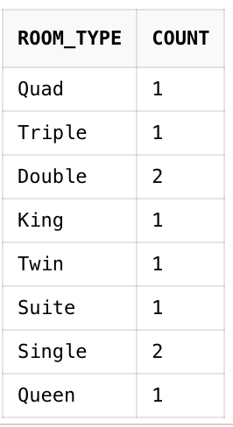

1. Calculate the total prices of a reservation period of a specific period for all the rooms with prices above 500

select d.reserv_date ,r.room_no, r.room_type, h.hotel_name,(d.reserv_period * r.room_price) AS total

from reservation d, room r, hotel h

where (d.room_id = r.room_id AND r.hotel_id = h.hotel_id) AND r.room_type in (select room_type From room Where room_price >= 500)

1. Display all customers from France, china, Brazil and Albania whose first name includes ‘a’

select cust_fname AS name, cust_email AS email,cust_address AS address

from customer

Where cust_fname Like '%a%' and cust_address in ('China','France','Albania','Brazil')

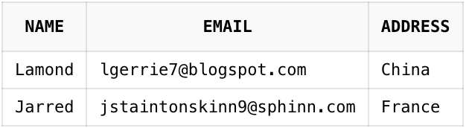

1. Update the availability of room number ‘2-01’ to F

Update room set room_availability = 'F' where room_no = '2-01';

select * from room where room_no = '2-01';

1. Display all payments made between January 8, 2022, and November 28, 2022

select * from payment where payment_date between '08-Jan-2022' and '28-Nov-2022'

1. Display the average prices of each room types

select room_type, Avg(room_price)

from room

Group by room_type;

1. Display the maxium times a single room is booked.

select max(count(room_id)) from reservation group by room_id;

1. Group Rooms by their booking frequency and display only those which have been booked 2 and more times.

select Room_Type, count(Room_Type) from Room group by Room_Type having count(room_type) >=2;

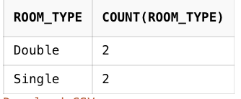

1. Display the date on which invoice is generated in descending order.

Sselect Issue_Date from invoice order by Issue_Date desc;

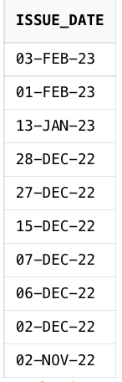

1. Join Customer and their Payment Info

SELECT Customer.Cust_FNAME, Payment.Payment_ID

FROM Customer

INNER JOIN Payment ON Customer.Cust_ID = Payment.Cust_ID;

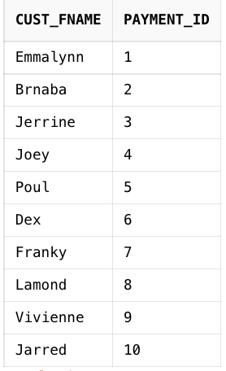

# **PART III: Implementation - Advanced SQL Related**

1. If reserve period is more than five days, reduce the price by 5% for each booking after the 5th day, and calculate total price based on the reserve duration.

CREATE OR REPLACE PROCEDURE DURATION_OFFER(stay in number, room_booked in varchar)

IS

one_night number;

total_amount number;

BEGIN

select room_price into one_night from room where room_id = room_booked;

if (stay > 5) then

total_amount := 0.95 * (stay - 5) * one_night;

DBMS_OUTPUT.PUT_LINE('The Total Price after the offer is: '|| total_amount);

else

DBMS_OUTPUT.PUT_LINE('Sorry, the offer does not apply to reserve period less than 5 days!');

end if;

END;

To call:

DECLARE

aa number;

bb char(8);

BEGIN

aa := 10;

bb := '3';

DURATION_OFFER(aa,bb);

END;

1. Create Trigger, Function and Procedure

**#Trigger**

Give 15% discount on weekends for room.

Create or Replace Trigger Discount_on_Weekend

before insert on room

for each row

begin

IF TO_CHAR(SYSDATE, 'DAY') BETWEEN 'SATURDAY' AND 'MONDAY'

THEN

:new.room_price := :new.room_price - .15 * :new.room_price;

end if;

end;

1. **#Trigger**

Create or Replace Trigger Sanitation

before insert or update on reservation

for each row

begin

if TO_CHAR(SYSDATE, 'HH12:MI') between '7:00 PM' and '12:00 AM' THEN

RAISE_APPLICATION_ERROR(-20001,'The booking is closed');

end if;

end;

1. FUNCTION

Create a function which computes the total number of bookings in a given month.

CREATE OR REPLACE FUNCTION RESERVATION_IN_MONTH(mnth in varchar)

RETURN NUMBER

IS

times NUMBER(4);

BEGIN

select COUNT(reserv_date) INTO TIMES from reservation where TO_CHAR(reserv_date, 'MON') = mnth;

RETURN TIMES;

END;

BEGIN

DBMS_OUTPUT.PUT_LINE(RESERVATION_IN_MONTH('JAN') || ' bookings have been made.');

END;

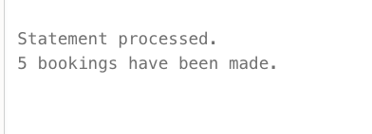

# **PART IV: Setup MySQL Database Server and PHP Web App**

## **MySQL Scripts**

*--*

*-- Database: `hotel_management_system`*

*--*

CREATE DATABASE IF NOT EXISTS `hotel_management_system` DEFAULT CHARACTER SET utf8mb4 COLLATE utf8mb4_general_ci;

USE `hotel_management_system`;

*-- --------------------------------------------------------*

*--*

*-- Table structure for table `Customer`*

*--*

CREATE TABLE `Customer` (

`cust_id` char(8) NOT NULL,

`cust_Fname` varchar(30) NOT NULL,

`cust_Lname` varchar(30) NOT NULL,

`cust_Email` varchar(30) NOT NULL,

`cust_Phone_No` varchar(20) DEFAULT NULL,

`cust_Address` varchar(20) DEFAULT NULL

) ENGINE=InnoDB DEFAULT CHARSET=utf8mb4;

*--*

*-- Dumping data for table `Customer`*

*--*

INSERT INTO `Customer` (`cust_id`, `cust_Fname`, `cust_Lname`, `cust_Email`, `cust_Phone_No`, `cust_Address`) VALUES

('1', 'Emmalynn', 'Pimerick', 'epimerick0@hostgator.com', '311-315-8577', 'Poland'),

('10', 'Jarred', 'Stainton - Skinn', 'jstaintonskinn9@sphinn.com', '561-728-5819', 'France'),

('2', 'Brnaba', 'Gorry', 'bgorry1@canalblog.com', '459-614-7277', 'Philippines'),

('3', 'Jerrine', 'Gorman', 'jgorman2@mashable.com', '663-243-7418', 'France'),

('4', 'Joey', 'Hatwell', 'jhatwell3@intel.com', '264-985-0938', 'China'),

('5', 'Poul', 'Fuge', 'pfuge4@vinaora.com', '304-838-7585', 'Tunisia'),

('6', 'Dex', 'Sifflett', 'dsifflett5@ox.ac.uk', '259-984-5382', 'Brazil'),

('7', 'Franky', 'Covotto', 'fcovotto6@uiuc.edu', '542-435-0473', 'Macedonia'),

('8', 'Lamond', 'Gerrie', 'lgerrie7@blogspot.com', '791-723-4674', 'China'),

('9', 'Vivienne', 'Pullin', 'vpullin8@wikipedia.org', '248-841-1074', 'Albania');

*-- --------------------------------------------------------*

*--*

*-- Table structure for table `Hotel`*

*--*

CREATE TABLE `Hotel` (

`hotel_id` char(8) NOT NULL,

`hotel_name` varchar(40) NOT NULL,

`hotel_loc` varchar(40) NOT NULL

) ENGINE=InnoDB DEFAULT CHARSET=utf8mb4;

*--*

*-- Dumping data for table `Hotel`*

*--*

INSERT INTO `Hotel` (`hotel_id`, `hotel_name`, `hotel_loc`) VALUES

('1', 'Scarlet Horizon Hotel', '45 Buell Plaza'),

('10', 'Serene Gem Hotel', '0000 Esker Parkway'),

('2', 'Lord Monarch Hotel', '74 Summerview Drive'),

('3', 'Rau, Schiller & Crooks', '78416 Rowland Avenue'),

('4', 'Dual Aegis Resort', '58 Dennis Lane'),

('5', 'Mellow Cosmos Hotel', '8 Dryden Hill'),

('6', 'Twin Phoenix Hotel', '81 Browning Road'),

('7', 'Riverside Bliss Hotel', '0 Cardinal Road'),

('8', 'Nicolas-Nitzsche', '490 Coolidge Drive'),

('9', 'Sunny Estate Hotel & Spa', '222 Vidon Pass');

*-- --------------------------------------------------------*

*--*

*-- Table structure for table `Invoice`*

*--*

CREATE TABLE `Invoice` (

`invoice_id` char(8) NOT NULL,

`issue_date` datetime NOT NULL,

`payment_id` char(8) NOT NULL

) ENGINE=InnoDB DEFAULT CHARSET=utf8mb4;

*--*

*-- Dumping data for table `Invoice`*

*--*

INSERT INTO `Invoice` (`invoice_id`, `issue_date`, `payment_id`) VALUES

('1', '2023-02-09 00:00:00', '1'),

('10', '2023-02-08 00:00:00', '10'),

('2', '2023-12-12 00:00:00', '2'),

('3', '2022-12-20 00:00:00', '3'),

('4', '2022-12-27 00:00:00', '4'),

('5', '2022-12-12 00:00:00', '5'),

('6', '2022-12-10 00:00:00', '6'),

('7', '2023-01-23 00:00:00', '7'),

('8', '2022-12-27 00:00:00', '8'),

('9', '2022-11-24 00:00:00', '9');

*-- --------------------------------------------------------*

*--*

*-- Table structure for table `Payment`*

*--*

CREATE TABLE `Payment` (

`payment_id` char(8) NOT NULL,

`payment_date` datetime NOT NULL,

`payment_method` varchar(10) NOT NULL,

`cust_id` char(8) NOT NULL,

`reserv_id` char(8) NOT NULL

) ENGINE=InnoDB DEFAULT CHARSET=utf8mb4;

*--*

*-- Dumping data for table `Payment`*

*--*

INSERT INTO `Payment` (`payment_id`, `payment_date`, `payment_method`, `cust_id`, `reserv_id`) VALUES

('1', '2022-12-20 00:00:00', 'card', '1', '1'),

('10', '2022-12-22 00:00:00', 'card', '10', '10'),

('2', '2023-01-23 00:00:00', 'cash', '2', '2'),

('3', '2022-12-22 00:00:00', 'cash', '3', '3'),

('4', '2023-01-12 00:00:00', 'card', '4', '4'),

('5', '2022-12-18 00:00:00', 'cash', '5', '5'),

('6', '2023-01-15 00:00:00', 'card', '6', '6'),

('7', '2022-11-02 00:00:00', 'card', '7', '7'),

('8', '2023-01-27 00:00:00', 'cash', '8', '8'),

('9', '2022-11-15 00:00:00', 'card', '9', '9');

*-- --------------------------------------------------------*

*--*

*-- Table structure for table `Reservation`*

*--*

CREATE TABLE `Reservation` (

`reserv_id` char(8) NOT NULL,

`reserv_date` datetime NOT NULL,

`reserv_period` tinyint(4) NOT NULL,

`room_id` char(8) NOT NULL,

`cust_id` char(8) NOT NULL

) ENGINE=InnoDB DEFAULT CHARSET=utf8mb4;

*--*

*-- Dumping data for table `Reservation`*

*--*

INSERT INTO `Reservation` (`reserv_id`, `reserv_date`, `reserv_period`, `room_id`, `cust_id`) VALUES

('1', '2022-01-22 00:00:00', 23, '1', '1'),

('10', '2022-01-23 00:00:00', 26, '10', '10'),

('2', '2022-11-20 00:00:00', 11, '2', '2'),

('3', '2022-12-22 00:00:00', 28, '3', '3'),

('4', '2022-01-23 00:00:00', 28, '4', '4'),

('5', '2022-12-20 00:00:00', 14, '5', '5'),

('6', '2022-01-23 00:00:00', 10, '6', '6'),

('7', '2022-12-22 00:00:00', 9, '7', '7'),

('8', '2022-01-20 00:00:00', 18, '8', '8'),

('9', '2022-12-22 00:00:00', 15, '9', '9');

*-- --------------------------------------------------------*

*--*

*-- Table structure for table `Review`*

*--*

CREATE TABLE `Review` (

`review_id` char(8) NOT NULL,

`feedback` varchar(255) DEFAULT NULL,

`rate` tinyint(4) DEFAULT NULL CHECK (`rate` <= 5),

`cust_id` char(8) NOT NULL,

`hotel_id` int(11) NOT NULL DEFAULT 4

) ENGINE=InnoDB DEFAULT CHARSET=utf8mb4;

*--*

*-- Dumping data for table `Review`*

*--*

INSERT INTO `Review` (`review_id`, `feedback`, `rate`, `cust_id`, `hotel_id`) VALUES

('1', 'Great view of Dubai skyline,pool area is very relaxing and clean. The room is very luxurious with a big bath and modern decor room. The gym is great, has a lot of equipment', 5, '1', 4),

('10', 'This resort was absolutely beautiful, great location, great facilities, great staff and wonderful food in the Crescendo Restaurant. Lagoon pool rooms were beautiful and very clean.', 5, '6', 1),

('2', 'The beds are comfortable and there is plenty of drawers and closets for a full week or more for a family in the room.', 4, '10', 4),

('3', 'Gorgeous design, friendly staff, clean and safe atmosphere. Fantastic restaurants and cafe within. We also booked couples massages. We enjoyed the pool and variety of options if we stayed in.', 5, '3', 8),

('4', 'The lobby is just breathtaking and we had gone through the VIP check in majlis. Our room (regal suite) is very spacious and elegant. The bathroom and Closet room was just marvelous.', 4, '8', 2),

('5', 'Clean, fun, great breakfast, and fantastic service! Nice central location as well. Highly recommend as it is a great price you can’t beat for the quality received. Cinema and dining added bonus.', 3, '5', 4),

('6', 'Well managed, clean spot with great Thai cuisine, good Lebanese restaurant. The pools and facilities are new and of high standard. Its a great idea to organize the cinema events at the beach at night time.', 4, '9', 7),

('7', 'The gym is very good and well equipped. The sauna and steam room were a real highlight too. The rooms are spacious, clean and comfortable. All the staff are friendly, welcoming and so helpful.', 5, '7', 4),

('8', 'The room was spacious, with a comfy bed. Breakfast was fantastic, with accommodating staff. The hotel has an excellent pool with an exciting shape. It indeed was definitely would come again hotel.', 4, '4', 10),

('9', 'Location is also good, most things a short taxi ride away. Swimming pool, gym and spa available. Samuel and Anil did a really good job of servicing our rooms, always getting us what we need.', 4, '2', 4);

*-- --------------------------------------------------------*

*--*

*-- Table structure for table `Room`*

*--*

CREATE TABLE `Room` (

`room_id` char(8) NOT NULL,

`room_no` varchar(10) NOT NULL,

`room_type` varchar(10) NOT NULL,

`room_price` decimal(7,2) NOT NULL,

`room_availability` char(1) NOT NULL,

`img` text NOT NULL,

`hotel_id` char(8) NOT NULL

) ENGINE=InnoDB DEFAULT CHARSET=utf8mb4;

*--*

*-- Dumping data for table `Room`*

*--*

INSERT INTO `Room` (`room_id`, `room_no`, `room_type`, `room_price`, `room_availability`, `img`, `hotel_id`) VALUES

('1', '201', 'Single', '181.76', 'T', 'single1.jpeg', '1'),

('10', '2-13', 'Single', '395.92', 'T', 'single10.jpeg', '10'),

('11', '1-50', 'twin', '569.74', 'T', 'twin4.jpg', '4'),

('12', '0-45', 'double', '2400.00', 'T', 'double4.jpg', '4'),

('13', '2-10', 'single', '395.92', 'F', 'single4.jpeg', '4'),

('2', '2-02', 'Double', '222.82', 'F', 'double2.jpg', '2'),

('3', '2-11', 'Triple', '265.03', 'F', 'triple3.jpeg', '3'),

('4', '2-42', 'King', '1137.79', 'T', 'king4.jpg', '4'),

('5', '3-15', 'Queen', '782.72', 'T', 'queen5.jpeg', '5'),

('6', '2-23', 'Twin', '569.74', 'T', 'twin6.jpg', '6'),

('7', '4-09', 'Quad', '1073.14', 'T', 'quad7.jpeg', '7'),

('8', '4-01', 'Double', '2254.51', 'F', 'double8.jpg', '8'),

('9', '3-19', 'Suite', '3419.20', 'F', 'suite9.jpg', '9');

*--*

*-- Indexes for dumped tables*

*--*

*--*

*-- Indexes for table `Customer`*

*--*

ALTER TABLE `Customer`

ADD PRIMARY KEY (`cust_id`);

*--*

*-- Indexes for table `Hotel`*

*--*

ALTER TABLE `Hotel`

ADD PRIMARY KEY (`hotel_id`);

*--*

*-- Indexes for table `Invoice`*

*--*

ALTER TABLE `Invoice`

ADD PRIMARY KEY (`invoice_id`),

ADD KEY `fk_invoice_payment` (`payment_id`);

*--*

*-- Indexes for table `Payment`*

*--*

ALTER TABLE `Payment`

ADD PRIMARY KEY (`payment_id`),

ADD KEY `fk_payment_customer` (`cust_id`),

ADD KEY `fk_payment_reservation` (`reserv_id`);

*--*

*-- Indexes for table `Reservation`*

*--*

ALTER TABLE `Reservation`

ADD PRIMARY KEY (`reserv_id`),

ADD KEY `fk_reservation_customer` (`cust_id`),

ADD KEY `fk_reservation_room` (`room_id`);

*--*

*-- Indexes for table `Review`*

*--*

ALTER TABLE `Review`

ADD PRIMARY KEY (`review_id`),

ADD KEY `fk_review_customer` (`cust_id`);

*--*

*-- Indexes for table `Room`*

*--*

ALTER TABLE `Room`

ADD PRIMARY KEY (`room_id`),

ADD UNIQUE KEY `room_id` (`room_id`),

ADD KEY `fk_room_hotel` (`hotel_id`);

*--*

*-- Constraints for dumped tables*

*--*

*--*

*-- Constraints for table `Invoice`*

*--*

ALTER TABLE `Invoice`

ADD CONSTRAINT `fk_invoice_payment` FOREIGN KEY (`payment_id`) REFERENCES `Payment` (`payment_id`);

*--*

*-- Constraints for table `Payment`*

*--*

ALTER TABLE `Payment`

ADD CONSTRAINT `fk_payment_customer` FOREIGN KEY (`cust_id`) REFERENCES `Customer` (`cust_id`),

ADD CONSTRAINT `fk_payment_reservation` FOREIGN KEY (`reserv_id`) REFERENCES `Reservation` (`reserv_id`);

*--*

*-- Constraints for table `Reservation`*

*--*

ALTER TABLE `Reservation`

ADD CONSTRAINT `fk_reservation_customer` FOREIGN KEY (`cust_id`) REFERENCES `Customer` (`cust_id`),

ADD CONSTRAINT `fk_reservation_room` FOREIGN KEY (`room_id`) REFERENCES `Room` (`room_id`);

*--*

*-- Constraints for table `Review`*

*--*

ALTER TABLE `Review`

ADD CONSTRAINT `fk_review_customer` FOREIGN KEY (`cust_id`) REFERENCES `Customer` (`cust_id`);

*--*

*-- Constraints for table `Room`*

*--*

ALTER TABLE `Room`

ADD CONSTRAINT `fk_room_hotel` FOREIGN KEY (`hotel_id`) REFERENCES `Hotel` (`hotel_id`);

COMMIT;

*/*!40101 SET CHARACTER_SET_CLIENT=@OLD_CHARACTER_SET_CLIENT */*;

*/*!40101 SET CHARACTER_SET_RESULTS=@OLD_CHARACTER_SET_RESULTS */*;

*/*!40101 SET COLLATION_CONNECTION=@OLD_COLLATION_CONNECTION */*;

## **PHP Scripts**

**db.php**

<?php

// constants for connection

define('HOSTNAME', 'localhost');

define('DATABASE', 'id19831983_hotel_management_system');

define('USERNAME', 'id19831983_mekson');

define('PASSWORD', 'yA%]QU+gbwm5n]3~');

$connection = mysqli_connect(HOSTNAME, USERNAME, PASSWORD, DATABASE);

if (!$connection) die('Database Access Failed no connection ' . mysqli_connect_errno());

**controller.php**

<?php require_once('../db/db.php');

header('Access-Control-Allow-Origin:*');

header('Content-Type:application/json');

header('Access-Control-Allow-Methods: POST, GET, PUT, OPTIONS, PATCH, DELETE');

header('Access-Control-Allow-Headers: *');

$request = $_POST['request'];

$result = "";

switch ($request) {

case "GET_ALL_ROOMS":

$result = get_all_rooms($connection);

break;

case "BOOK_A_ROOM":

$result = book_a_room($connection,$_POST['id'],$_POST['custId'],$_POST['roomId'],$_POST['date'],$_POST['period']);

break;

case "GET_HOTEL_DETAILS":

$result = get_hotel_details($connection,$_POST['name']);

break;

case "GET_HOTELS":

$result = get_hotels($connection);

break;

case "GET_ROOMS":

$result = get_rooms($connection,$_POST['id']);

break;

default:

return '';

}

echo $result;

function get_all_rooms($connection)

{

$query = "SELECT R.room_no AS no, R.room_type AS type, R.room_price AS price, R.room_availability As availability,H.hotel_name As hotel_name,H.hotel_loc AS location ";

$query .= "FROM Room R, Hotel H ";

$query .= "WHERE H.hotel_id = R.hotel_id";

$result = mysqli_query($connection, $query);

if (!$result) die('Database operation failed get all rooms' . mysqli_connect_errno());

$data =array();

while ($row = mysqli_fetch_assoc($result)) {

$room = array();

$room['room_no'] = $row['no'];

$room['type'] = $row['type'];

$room['price'] = $row['price'];

$room['availability'] = $row['availability'];

$room['hotel_name'] = $row['hotel_name'];

$room['location'] = $row['location'];

$data[] = $room;

}

return json_encode($data);

}

function book_a_room($connection,$id,$customer,$room,$date,$period)

{

$query = "INSERT INTO Reservation (reserv_id,reserv_date,reserv_period,room_id,cust_id) ";

$query .= "VALUES ($id,'$date',$period,$room,$customer)";

$result = mysqli_query($connection, $query);

if (!$result) die('Database operation failed' . mysqli_connect_error());

return json_encode(array('success'=>true));

}

function get_rooms($connection,$id){

$query = "SELECT r.room_id AS id, r.room_no AS no FROM Room r, Hotel h WHERE r.hotel_id = h.hotel_id AND h.hotel_id = '$id'";

$result = mysqli_query($connection,$query);

if (!$result) die('Database operation failed ' . mysqli_connect_errno());

$data = array();

while ($row = mysqli_fetch_assoc($result)) {

$room = array();

$room['id'] = $row['id'];

$room['no'] = $row['no'];

$data[] = $room;

}

return json_encode($data);

}

function get_hotels($connection){

$query = "SELECT hotel_id, hotel_name FROM Hotel";

$result = mysqli_query($connection,$query);

if (!$result) die('Database operation failed ' . mysqli_connect_errno());

$data = array();

while ($row = mysqli_fetch_assoc($result)) {

$hotel = array();

$hotel['id'] = $row['hotel_id'];

$hotel['name'] = $row['hotel_name'];

$data[] = $hotel;

}

return json_encode($data);

}

function get_hotel_details($connection,$name){

$query = "SELECT R.room_type AS type, R.room_price AS price, H.hotel_name As name, R.img,R.hotel_id As id ";

$query .= "FROM Room R, Hotel H ";

$query .= "WHERE R.hotel_id = H.hotel_id && H.hotel_name = '$name'" ;

$result = mysqli_query($connection,$query);

if (!$result) die('Database operation failed ' . mysqli_connect_errno());

$data =array();

$review = array();

$id = '';

while ($row = mysqli_fetch_assoc($result)) {

$room = array();

$room['type'] = $row['type'];

$room['price'] = $row['price'];

$room['hotel_name'] = $row['name'];

$room['img'] = $row['img'];

$id = $row['id'];

$data[] = $room;

}

$query2 = "SELECT R.feedback AS feedback, R.rate AS rate, C.cust_Fname AS name ";

$query2 .= "FROM Review R, Customer C ";

$query2 .= "WHERE C.cust_id = R.cust_id && R.hotel_id = '$id' ";

$result2 = mysqli_query($connection,$query2);

if (!$result2) die('Database operation failed ' . mysqli_error($connection));

while ($row2 = mysqli_fetch_assoc($result2)) {

$item = array();

$item['feedback'] = $row2['feedback'];

$item['rate'] = $row2['rate'];

$item['name'] = $row2['name'];

$review[] = $item;

}

$final_result = array($data,$review);

return json_encode($final_result);

}

## **Javascript**

const getAllRooms = () => {

$.ajax({

method: "POST",

url: "https://hotelmanagementbooking.000webhostapp.com/controller/controller.php",

dataType: "json",

data: { request: "GET_ALL_ROOMS" },

success: function (data) {

generateTable(data);

},

});

};

const getHotelDetails = () => {

let params = new URLSearchParams(location.search);

const hotel = params.get("hotel");

$.ajax({

method: "POST",

url: "https://hotelmanagementbooking.000webhostapp.com/controller/controller.php",

dataType: "json",

data: { request: "GET_HOTEL_DETAILS", name: hotel },

success: function (data) {

generateHotelDetails(data[0], hotel);

generateReviews(data[1]);

},

});

};

const bookRoom = (e) => {

e.preventDefault();

console.log('adf')

const custId = $('#cust_id').val();

const roomId = $('#rooms').val();

const date = $('#date').val();

const period = $('#period').val();

$.ajax({

method: "POST",

url: "https://hotelmanagementbooking.000webhostapp.com/controller/controller.php",

dataType: "json",

data: { request: "BOOK_A_ROOM",id:Math.floor(Math.random() * 1000), custId,roomId,date,period },

success: function (data) {

*if* (data['success']){

alert("Thanks for booking with us")

}

},

});

}

const getHotels = () => {

$.ajax({

method: "POST",

url: "https://hotelmanagementbooking.000webhostapp.com/controller/controller.php",

dataType: "json",

data: { request: "GET_HOTELS" },

success: function (data) {

let html = "";

data.forEach((hotel) => {

html += `<option value=${hotel.id} >${hotel.name}</option>`;

});

$("#hotels").html(html);

},

});

};

const getRooms = () => {

const id = $('#hotels').val() || '1';

$.ajax({

method: "POST",

url: "https://hotelmanagementbooking.000webhostapp.com/controller/controller.php",

dataType: "json",

data: { request: "GET_ROOMS",id },

success: function (data) {

let html = "";

data.forEach((room) => {

html += `<option value=${room.id} >${room.no}</option>`;

});

$("#rooms").html(html);

},

});

}

const generateTable = (data) => {

let html = "";

data.forEach((room) => {

const no = room.room_no;

const availability = room.availability === "T" ? "Yes" : "No";

const location = room.location;

const price = room?.price;

const type = room?.type;

const hotel = room?.hotel_name;

const style =

availability === "Yes" ? "background:#80de64" : "background:#eb4c46";

html += ` <tr >

<td>${no}</td>

<td>${type}</td>

<td>$${price}</td>

<td style='${style}'>${availability}</td>

<td><a href="./hotel.html?hotel=${hotel}">${hotel}</a></td>

<td>${location}</td>

</tr>`;

});

$("#table_body").html(html);

};

const generateHotelDetails = (data, name) => {

let html = "";

data.forEach((hotelRoom) => {

const type = hotelRoom?.type;

const price = hotelRoom?.price;

const hotel = hotelRoom?.hotel_name;

const image = hotelRoom?.img;

html += `

<div class="col-lg-3 col-sm-6">

<div class="accomodation_item text-center">

<div class="hotel_img">

<img src="https://hotelmanagementbooking.000webhostapp.com/assets/${image}" alt="" width='400px' />

<a href="#" class="btn theme_btn button_hover">Book Now</a>

</div>

<a href="#"><h4 class="sec_h4">${type}</h4></a>

<h5>$${price}<small>/night</small></h5>

</div>

</div>`;

});

$("#title").text(name);

$("#rooms").html(html);

};

const generateReviews = (data) => {

let html = "";

data.forEach((review) => {

const feedback = review?.feedback;

const rate = review?.rate;

const name = review?.name;

html += `

<div class="media testimonial_item">

<div class="media-body">

<p>

${feedback}

</p>

<a href="#"><h4 class="sec_h4">${name}</h4></a>

<div class="star">

${rate} <a href="#"><i class="fa fa-star"></i></a>

</div>

</div>

</div>

`;

});

$("#testimony").html(html);

};

## **PHP Web App**

NB. Website link

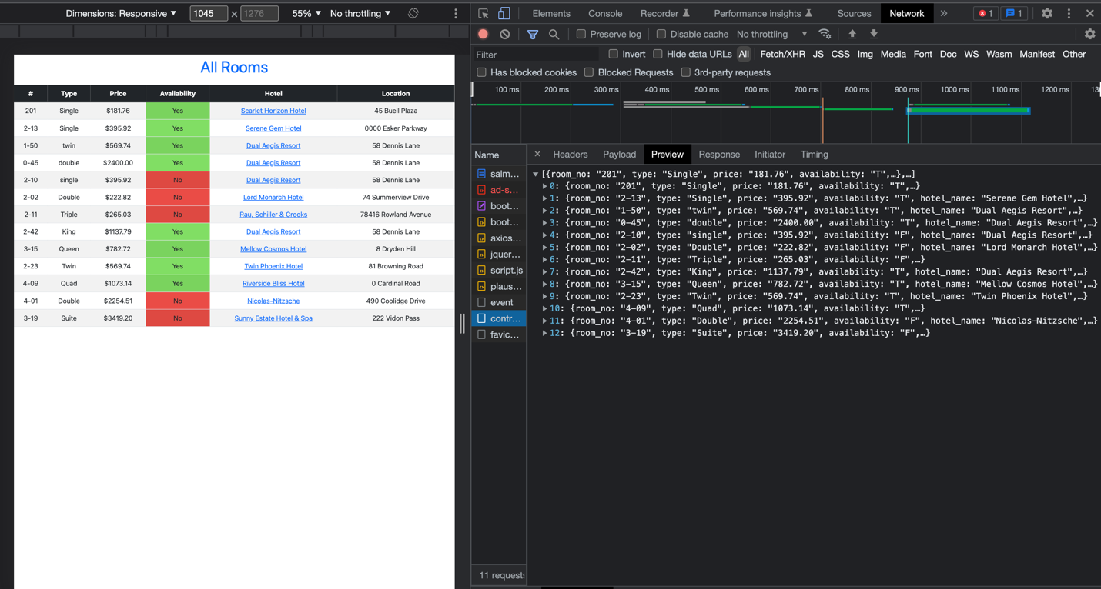**https://salmon-carlotta-75.tiiny.site/**



